EWBCOURSES
EWB CLOUD LABS
STUDENT PROJECT REPORT
BUILD / TEST / EXPLAIN
AWS
VPC Peering
Connect two VPCs.
Prove private connectivity.
AWS VPC Peering Between Two Amazon VPCs
Component | Details
VPC 1 | 28.0.0.0/16 — EC2 instance
VPC 2 | 28.200.0.0/16 — EC2 instance
Link | pcx — VPC peering connection
Summary | 2 VPCs / 2 EC2 instances / 1 private connection
AWS ARCHITECT ASSOCIATE
Field | Value
NAME | Sejal Patil
BATCH | Batch 1
PROJECT TITLE | AWS VPC Peering Between Two Amazon VPCs
AWS REGION | US East (Ohio), us-east-2
COMPLETION DATE | 17 October 2026

01 / OVERVIEW

Project objective
Connect two VPCs and check that private communication works.
In this project I connected two Amazon VPCs in the US East (Ohio) Region (us-east-2) using a VPC peering connection, so that an EC2 instance in each VPC can talk to the other using the IPv4 address assigned to it inside its VPC. I set up the route tables and security groups for both sides and tested the connection from the command line with ping and SSH.

What VPC peering is
VPC peering is a private, one-to-one network link between two VPCs. Traffic between them stays on the AWS network and does not need an internet gateway. Creating the peering connection is not enough on its own. Each VPC also needs a route to the other VPC's CIDR block that points to the peering connection, and the security groups must allow the traffic. Peering is not transitive, and the two VPCs cannot have overlapping CIDR blocks.

What I did
- Created two VPCs with CIDR blocks that do not overlap: 28.0.0.0/16 (VPC1) and 28.200.0.0/16 (VPC2).
- Created the peering connection EWB_VPC_Peering (pcx-003e95287deb1beb7), which shows Active.
- Added a route in each VPC that points to the other VPC through the peering connection.
- Set up security group rules for SSH and ICMP.
- Pinged in both directions using the instances' VPC IP addresses, and logged in by SSH to the VPC2 instance (which has no public IP) through the VPC1 instance.
- Saw one ping fail and then work again. Section 9 explains what my screenshots can and cannot show about that.

About my CIDR blocks
I used 28.0.0.0/16 and 28.200.0.0/16. These are not RFC 1918 private IPv4 ranges (10.0.0.0/8, 172.16.0.0/12 and 192.168.0.0/16); they are ordinary public internet address space. The AWS console still labels the instance addresses 'Private IPv4', and my route tables send this traffic to the peering connection, so the lab worked. A real network should use RFC 1918 ranges instead. The workbook uses 10.10.0.0/16 and 10.20.0.0/16.

About the evidence
Every value in this report comes from my screenshots, except where I say it comes from my own project notes. If a value is not visible in a screenshot, I have written that. Things the workbook asks for that I did not capture are marked 'Not captured'. Appendix B lists all of them.

02 / ARCHITECTURE

The network I built
Two VPCs, two EC2 instances and one peering connection.
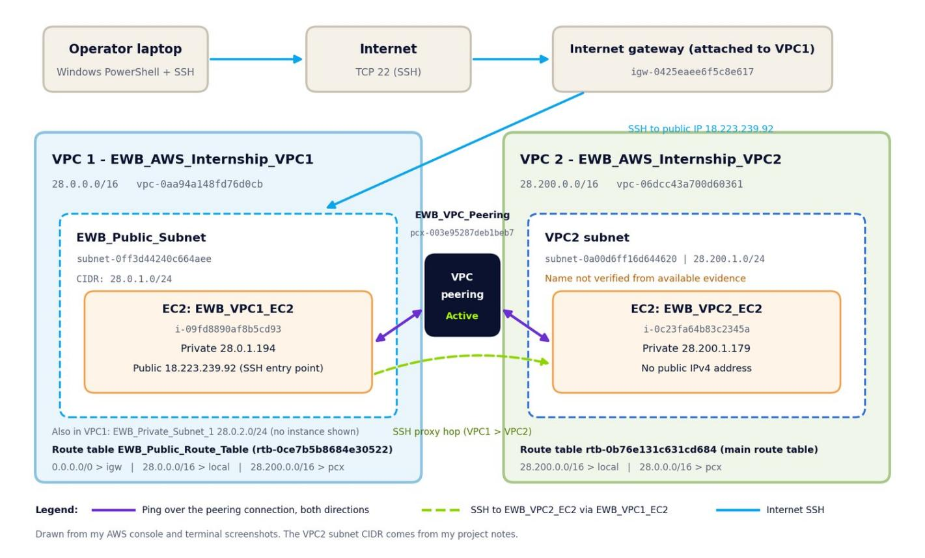
Figure 1. Architecture diagram drawn from my screenshots and notes (not a console screenshot).

Differences from the workbook design
The workbook expects a separate bastion host with a public IP and two application hosts with no public IP, plus three custom route tables and a private subnet in VPC A. I used two EC2 instances. EWB_VPC1_EC2 has a public IPv4 address and acts as both the bastion and the VPC1 host. EWB_VPC2_EC2 has no public IPv4 address. So my setup does not fully match the workbook design. The differences are:
Item | Workbook design | What I built
VPC CIDRs | 10.10.0.0/16 and 10.20.0.0/16 | 28.0.0.0/16 and 28.200.0.0/16 (no overlap)
Region | Example: ap-south-1 | us-east-2 (US East, Ohio)
EC2 instances | 3: bastion, App-A, App-B | 2: EWB_VPC1_EC2 (public IPv4, in the subnet that uses the public route table) and EWB_VPC2_EC2 (no public IPv4)
Bastion | Separate bastion in the VPC A public subnet | EWB_VPC1_EC2 is both the SSH entry point and the VPC1 ping endpoint
Private subnet in VPC A | ewb-a-private with its own route table | EWB_Private_Subnet_1 (28.0.2.0/24) exists, but I have no screenshot of an instance in it
Route tables | 3 custom tables with explicit associations | VPC1: EWB_Public_Route_Table (explicitly associated with the public subnet); the VPC1 subnet screenshots also show rtb-03c5f665332812b42. VPC2: main route table with no explicit association
Instance type / OS | t3.micro suggested, Amazon Linux 2023 | t2.micro, Amazon Linux 2023 (shown in the terminal banner)
SSH method | ProxyJump with one key pair | ssh with ProxyCommand (-W %h:%p) through the VPC1 instance, with a separate key file for each instance
ICMP rule on destination | Echo request from a single /32 | All ICMP - IPv4 from 28.0.0.0/16 (VPC2 security group)
Naming | Lowercase ewb-* names | EWB_* names (for example EWB_VPC_Peering)

03 / RESOURCE INVENTORY

Resources and IDs
Names, IDs and IP addresses used in this project.
Resource | Name | ID / value
VPC 1 | EWB_AWS_Internship_VPC1 | vpc-0aa94a148fd76d0cb | 28.0.0.0/16
VPC 2 | EWB_AWS_Internship_VPC2 | vpc-06dcc43a700d60361 | 28.200.0.0/16
VPC1 public subnet | EWB_Public_Subnet | subnet-0ff3d44240c664aee | 28.0.1.0/24 | us-east-2a
VPC1 private subnet | EWB_Private_Subnet_1 | subnet-05938eee98e06f0ea | 28.0.2.0/24 | us-east-2a
VPC2 subnet (*) | Name not verified from available evidence | subnet-0a00d6ff16d644620 | 28.200.1.0/24 | us-east-2a
Internet gateway (**) | Unnamed | igw-0425eaee6f5c8e617 | target in the VPC1 public route table
VPC1 public route table | EWB_Public_Route_Table | rtb-0ce7b5b8684e30522
VPC1 other route table (**) | Unnamed | rtb-03c5f665332812b42
VPC2 route table | Unnamed (main route table) | rtb-0b76e131c631cd684
Peering connection | EWB_VPC_Peering | pcx-003e95287deb1beb7 | Active before cleanup
Security group, VPC1 | EWB_VPC1_EC2_SG | sg-0efa2ba517a7929ec
Security group, VPC2 | EWB_VPC2_EC2_SG | sg-0c8df501681dc2efb
EC2 instance, VPC1 | EWB_VPC1_EC2 | i-09fd8890af8b5cd93 | private 28.0.1.194 | public 18.223.239.92
EC2 instance, VPC2 | EWB_VPC2_EC2 | i-0c23fa64b83c2345a | private 28.200.1.179 | no public IPv4

Notes on the inventory
(*) The only screenshot that shows the VPC2 subnet is the deletion message (Figure 25), which lists its ID but not its name or CIDR. Its name is not verified from available evidence. The CIDR 28.200.1.0/24 and the zone us-east-2a come from my project notes. (**) I did not record a Name tag for the internet gateway or for rtb-03c5f665332812b42, so they are listed as Unnamed.
Both instances are in us-east-2a. The list also shows a third VPC (172.31.0.0/16, vpc-0122188984f329f5c). That is the account's default VPC and is not part of this project.

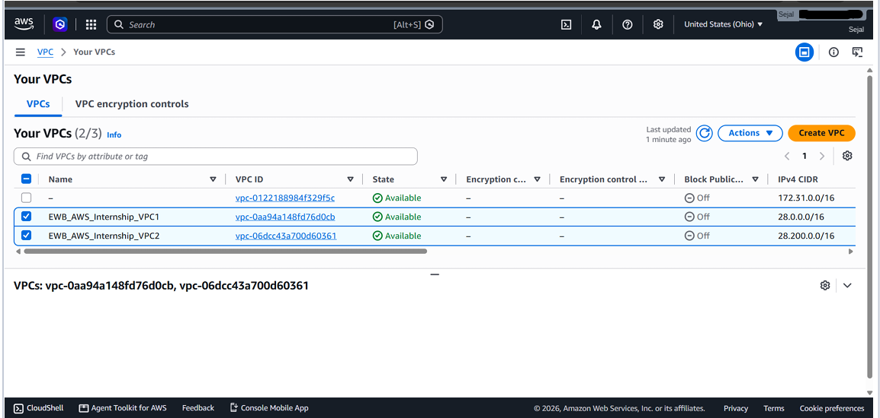
Figure 2. Your VPCs list: EWB_AWS_Internship_VPC1 (28.0.0.0/16) and EWB_AWS_Internship_VPC2 (28.200.0.0/16), both Available. The default VPC (172.31.0.0/16) is also listed.

04 / SUBNETS AND ROUTING

Subnets and route tables
The routes on both sides let traffic and replies use the peering connection.

Subnets
Subnet | ID | IPv4 CIDR | Auto-assign public IPv4 | Route table
EWB_Public_Subnet (VPC1) | subnet-0ff3d44240c664aee | 28.0.1.0/24 | No | rtb-03c5f665332812b42 at capture; later EWB_Public_Route_Table
EWB_Private_Subnet_1 (VPC1) | subnet-05938eee98e06f0ea | 28.0.2.0/24 | No | rtb-03c5f665332812b42
VPC2 subnet: name not verified from available evidence (*) | subnet-0a00d6ff16d644620 | 28.200.1.0/24 | Not captured | rtb-0b76e131c631cd684 (main)

The two VPC1 subnets are in vpc-0aa94a148fd76d0cb, us-east-2a. The IP address of EWB_VPC1_EC2, 28.0.1.194, is inside the public subnet's range. My subnet screenshots were taken before I linked the public subnet to EWB_Public_Route_Table, and a later screenshot shows that association. I have no screenshot of an instance in EWB_Private_Subnet_1.
(*) For VPC2, only the subnet ID appears in a screenshot (the deletion message). The name is not verified from available evidence. The CIDR and zone are from my project notes.
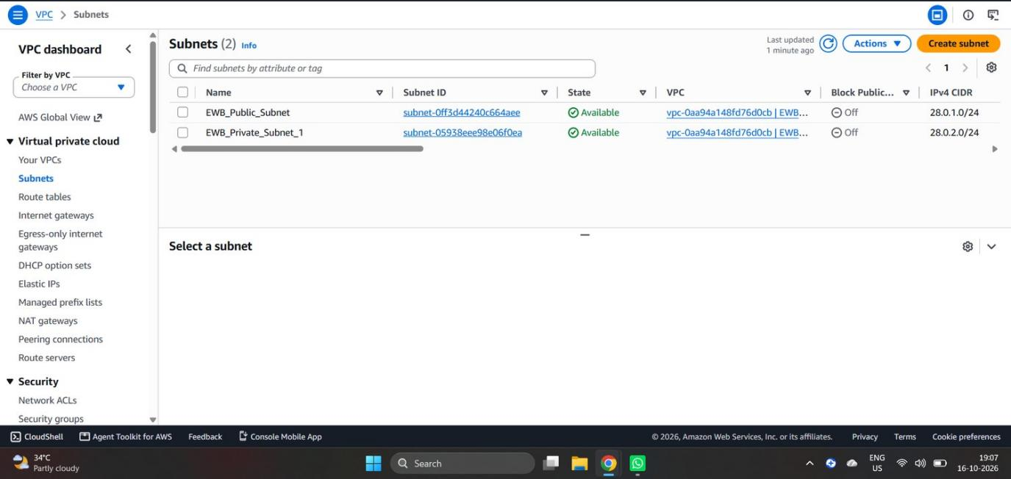
Figure 3. Subnets list taken before VPC2 was created: EWB_Public_Subnet (28.0.1.0/24) and EWB_Private_Subnet_1 (28.0.2.0/24) in VPC1.
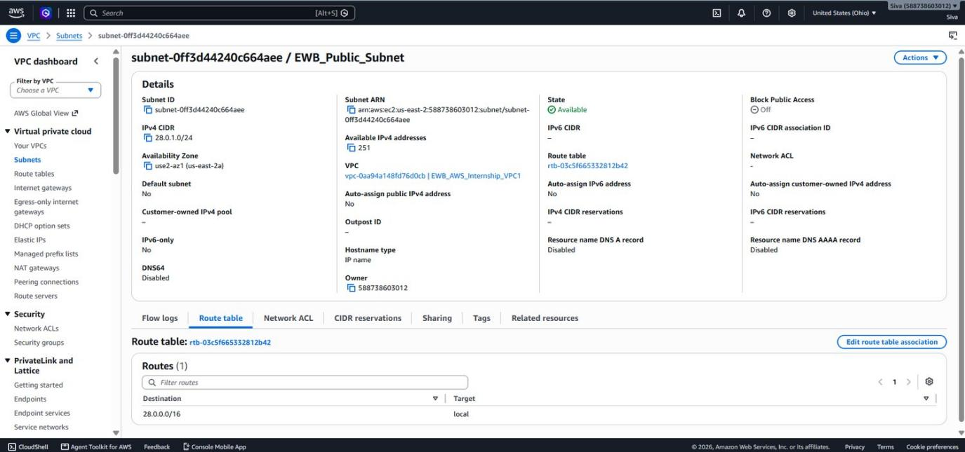
Figure 4. EWB_Public_Subnet (subnet-0ff3d44240c664aee): 28.0.1.0/24, us-east-2a, VPC1, auto-assign public IPv4 No. The route table shown is rtb-03c5f665332812b42 (local route only).
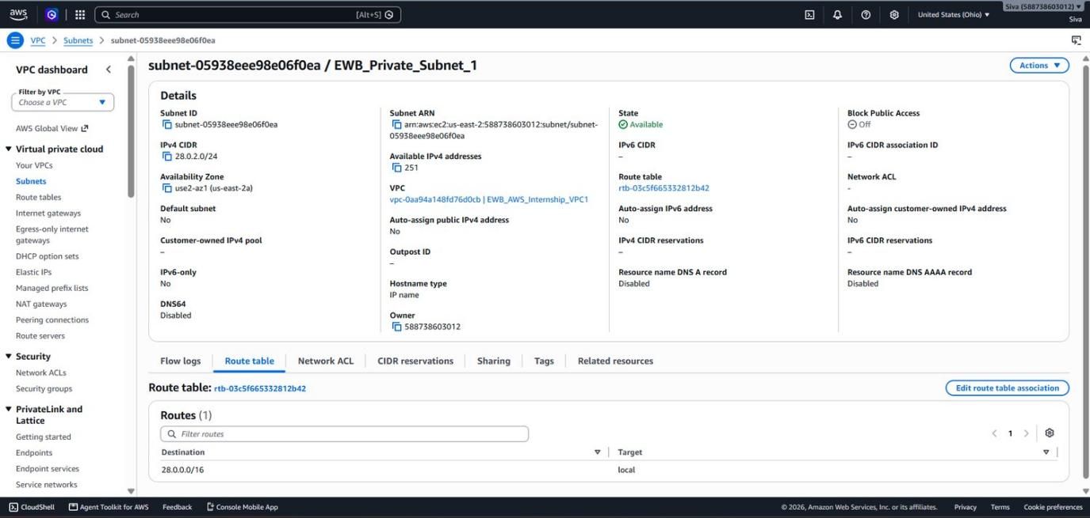
Figure 5. EWB_Private_Subnet_1 (subnet-05938eee98e06f0ea): 28.0.2.0/24, us-east-2a, VPC1, auto-assign public IPv4 No. The route table shown is rtb-03c5f665332812b42 (local route only).

EWB_Public_Route_Table (VPC1) - rtb-0ce7b5b8684e30522
Destination | Target | Status | Purpose
0.0.0.0/0 | igw-0425eaee6f5c8e617 | Active | Internet access (SSH from my laptop)
28.0.0.0/16 | local | Active | Traffic inside VPC1
28.200.0.0/16 | pcx-003e95287deb1beb7 | Active | Forward route to VPC2 through the peering connection

This table is explicitly associated with subnet-0ff3d44240c664aee (EWB_Public_Subnet). Main: No.

VPC2 route table - rtb-0b76e131c631cd684
Destination | Target | Status | Purpose
28.200.0.0/16 | local | Active | Traffic inside VPC2
28.0.0.0/16 | pcx-003e95287deb1beb7 | Active | Return route to VPC1 through the peering connection

This is the main route table of VPC2 and it has no explicit subnet association, so the VPC2 subnet uses it by default. It has no internet gateway route.
The route destinations match the VPC CIDRs: 28.200.0.0/16 on the VPC1 side and 28.0.0.0/16 on the VPC2 side. Because both sides have a route, replies can find their way back.
The other VPC1 route table, rtb-03c5f665332812b42 (Unnamed), appears only in the two VPC1 subnet screenshots, where it has just the local route 28.0.0.0/16. I did not capture it after peering was set up.

Route table before the peering route
Figure 6 shows EWB_Public_Route_Table right after I added the internet route. It has only the internet route and the local route, with no route to 28.200.0.0/16 and no subnet association yet. It shows how the table looked before I added the peering route. It is a configuration screenshot, not a ping test.
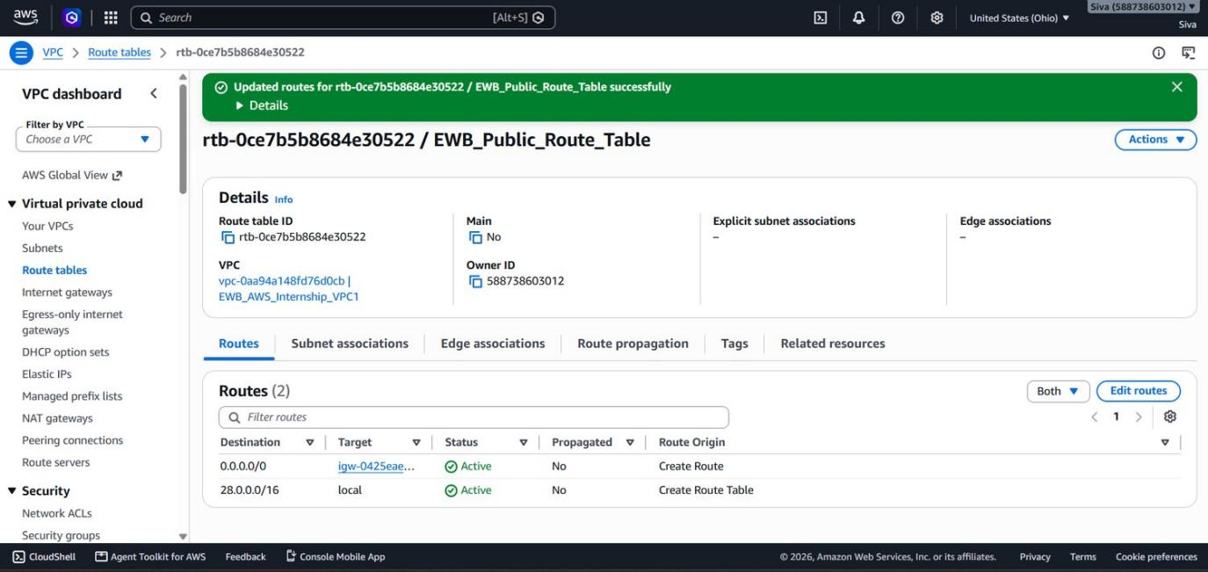
Figure 6. EWB_Public_Route_Table right after I added the internet route: only 0.0.0.0/0 to igw-0425eae... and 28.0.0.0/16 local. No route to 28.200.0.0/16 and no subnet association yet.
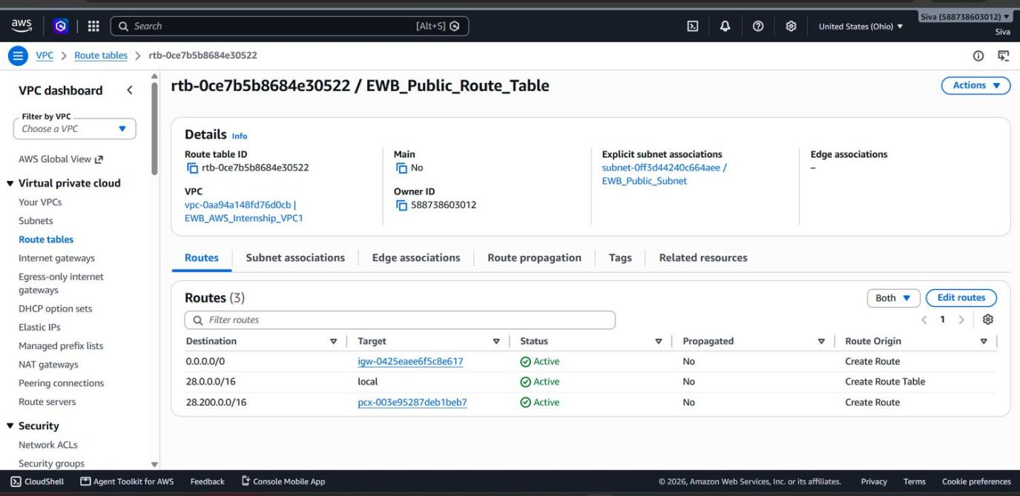
Figure 7. EWB_Public_Route_Table (rtb-0ce7b5b8684e30522), VPC1: three routes with full targets (igw-0425eaee6f5c8e617 and pcx-003e95287deb1beb7). This is the same table described in Section 4.
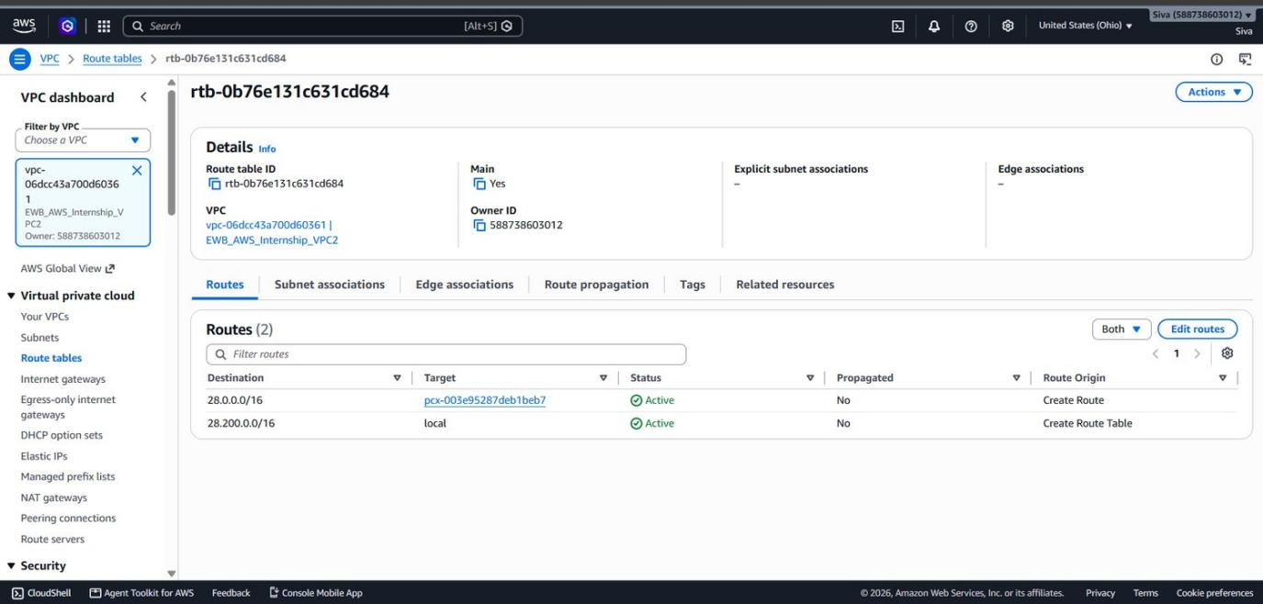
Figure 8. VPC2 route table rtb-0b76e131c631cd684 (Main: Yes, no explicit subnet associations) with the return route 28.0.0.0/16 to pcx-003e95287deb1beb7.

05 / PEERING CONNECTION

Request, accept, activate
The connection is the link. Routes and security groups decide what can use it.
Field | Value (from Figure 9)
Name / ID | EWB_VPC_Peering / pcx-003e95287deb1beb7
Status | Active (expiration time is blank)
Requester VPC / CIDR | vpc-0aa94a148fd76d0cb (EWB_AWS_Internship_VPC1) / 28.0.0.0/16
Accepter VPC / CIDR | vpc-06dcc43a700d60361 (EWB_AWS_Internship_VPC2) / 28.200.0.0/16
Requester and accepter Region | Ohio (us-east-2) for both
Requester and accepter owner | Same AWS account (both owner IDs are the same)
DNS resolution over peering | Disabled in both directions. My tests used IP addresses, so I did not need it.
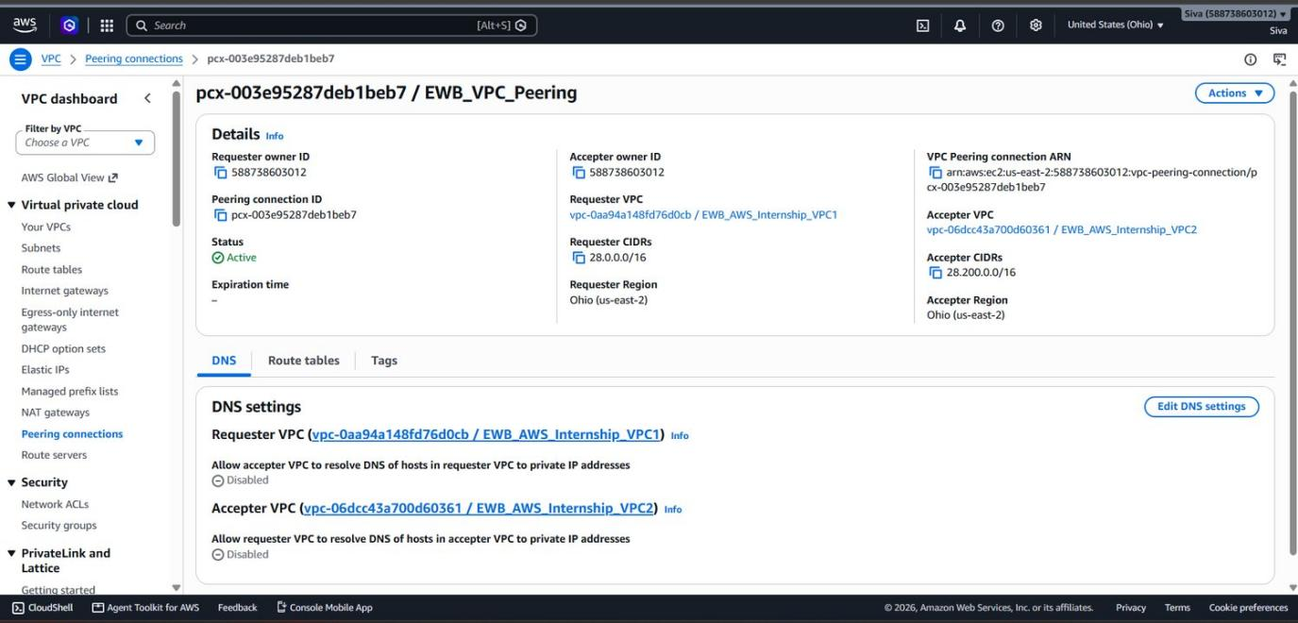
Figure 9. Peering connection pcx-003e95287deb1beb7 / EWB_VPC_Peering: Status Active, requester VPC1 (28.0.0.0/16), accepter VPC2 (28.200.0.0/16), both in us-east-2.
06 / SECURITY GROUPS

Inbound rules
Only the traffic needed for SSH and ping.

EWB_VPC1_EC2_SG - sg-0efa2ba517a7929ec (VPC1)
Rule ID | Type | Protocol / port | Source
sgr-02b08a2cc2b438b45 | All ICMP - IPv4 | ICMP / All | Not visible in screenshot
sgr-0955b40314606bd25 | SSH (IP version blank) | TCP / 22 | Not visible in screenshot
sgr-0bc49e4b0543b7efc | SSH (IPv4) | TCP / 22 | Not visible in screenshot

The console shows 3 inbound rules and 1 outbound rule for this group. The Source column is cut off in my screenshot and the outbound rule is not shown, so I cannot list them.

EWB_VPC2_EC2_SG - sg-0c8df501681dc2efb (VPC2)
Rule ID | Type | Protocol / port | Source
sgr-01b2b165d0479e581 | SSH | TCP / 22 | 223.191.77.27/32
sgr-08b782f87b7a9d202 | All ICMP - IPv4 | ICMP / All | 28.0.0.0/16
sgr-072463df914d0848f | SSH | TCP / 22 | 28.0.1.194/32 (VPC1 instance)

Figure 11 shows 3 inbound rules and 2 outbound rules; I cannot see what the outbound rules are. I also have an earlier screenshot of this group with only the first two rules, without the SSH rule for 28.0.1.194/32. I left it out because it does not show a capture time. The ICMP rule allows all ICMP from the whole VPC1 CIDR, which is wider than the workbook's single Echo-request /32 rule.
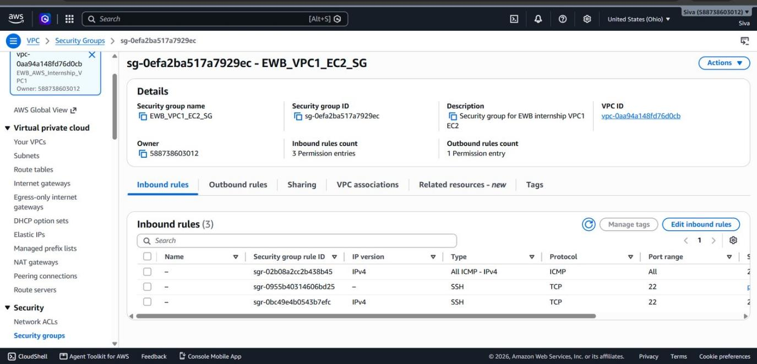
Figure 10. EWB_VPC1_EC2_SG (sg-0efa2ba517a7929ec): three inbound rules (All ICMP and two SSH). The Source column is cut off in this screenshot.
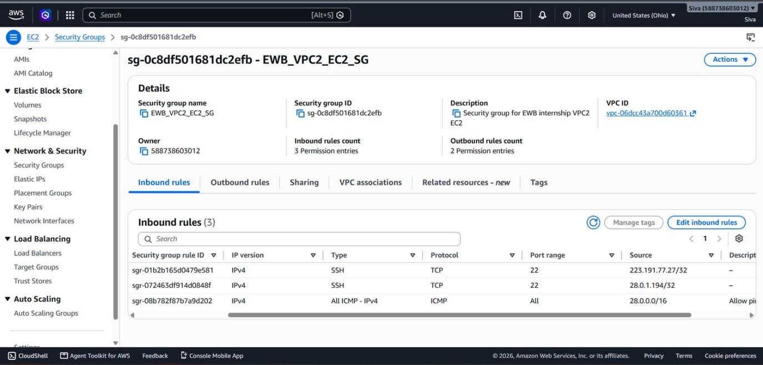
Figure 11. EWB_VPC2_EC2_SG: three inbound rules, including SSH (TCP 22) from 28.0.1.194/32, the IP address of EWB_VPC1_EC2.

07 / COMPUTE

EC2 instances
Two Amazon Linux 2023 instances. Only one has a public IP.
Field | EWB_VPC1_EC2 | EWB_VPC2_EC2
Instance ID | i-09fd8890af8b5cd93 | i-0c23fa64b83c2345a
State / status checks | Running / 2 of 2 passed | Running / 2 of 2 passed
Type / zone | t2.micro / us-east-2a | t2.micro / us-east-2a
Private IPv4 | 28.0.1.194 | 28.200.1.179
Public IPv4 | 18.223.239.92 | None (field empty)
Security group | EWB_VPC1_EC2_SG | EWB_VPC2_EC2_SG

The Public IPv4 field for EWB_VPC2_EC2 is empty, so that instance has no direct internet address. This is only one part of the workbook design: the workbook also expects a separate bastion and two private application hosts, and my setup has a public IPv4 address on the VPC1 instance and only two instances (see Section 2).
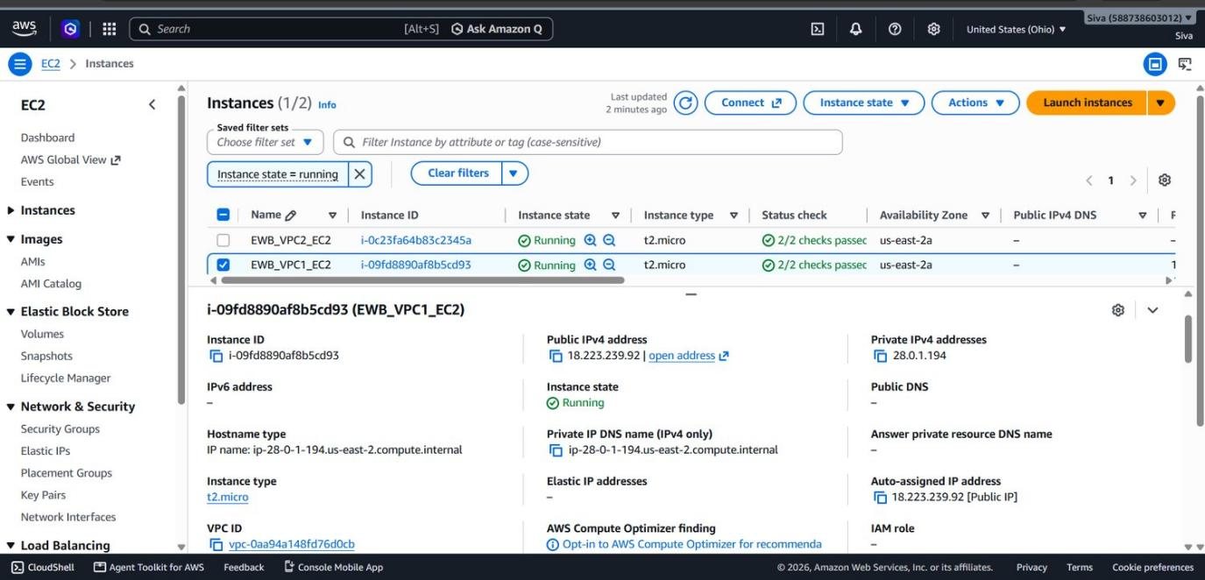
Figure 12. EWB_VPC1_EC2 (i-09fd8890af8b5cd93): Running, t2.micro, us-east-2a, private IPv4 28.0.1.194, public IPv4 18.223.239.92.
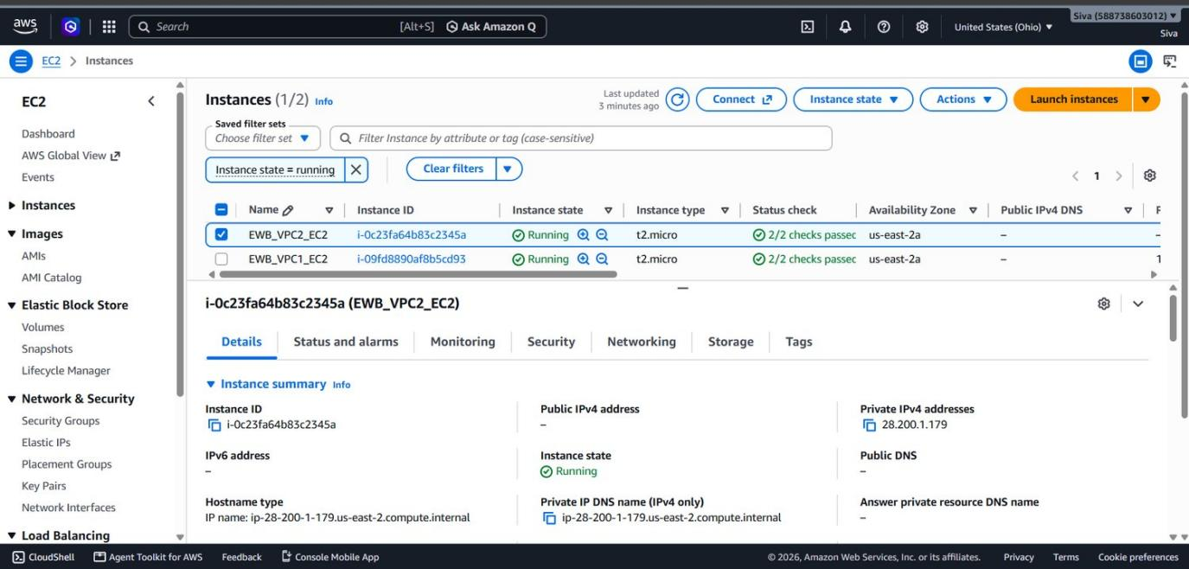
Figure 13. EWB_VPC2_EC2 (i-0c23fa64b83c2345a): Running, t2.micro, us-east-2a, private IPv4 28.200.1.179, Public IPv4 address empty.

08 / VERIFICATION

Connectivity tests
Results from my terminal screenshots.
Test | Where / command | Result | Figure
TCP 22 to VPC1 instance | Laptop: Test-NetConnection 18.223.239.92 -Port 22 | TcpTestSucceeded: True | Fig 14
SSH to VPC1 instance | Laptop: ssh to ec2-user@18.223.239.92 | Login worked (Amazon Linux 2023) | Fig 14
Forward ping | EWB_VPC1_EC2: ping -c 4 28.200.1.179 | 4 sent, 4 received, 0% loss; rtt min/avg/max 0.256/0.712/1.987 ms | Fig 14
Private SSH to VPC2 | Laptop: ssh with ProxyCommand through 18.223.239.92 to 28.200.1.179 | Login worked; banner shows last login from 28.0.1.194 | Fig 16, 15
Reverse ping | EWB_VPC2_EC2: ping -c 4 28.0.1.194 | 4 sent, 4 received, 0% loss; rtt min/avg/max 0.191/0.333/0.576 ms | Fig 15
Isolation | EC2 instance details, EWB_VPC2_EC2 | Public IPv4 address is empty | Fig 13
Baseline (before peering) | Workbook test 01: ping before peering and routes | Not captured as a test. I only have the route table screenshot from before the peering route was added (a configuration screenshot, not a result). | Fig 6

In Figure 16 I used ssh with a ProxyCommand (-W %h:%p) to reach the VPC2 instance through EWB_VPC2_EC2. The workbook uses ProxyJump, which does the same job. The VPC2 login banner shows an earlier login from 28.0.1.194.
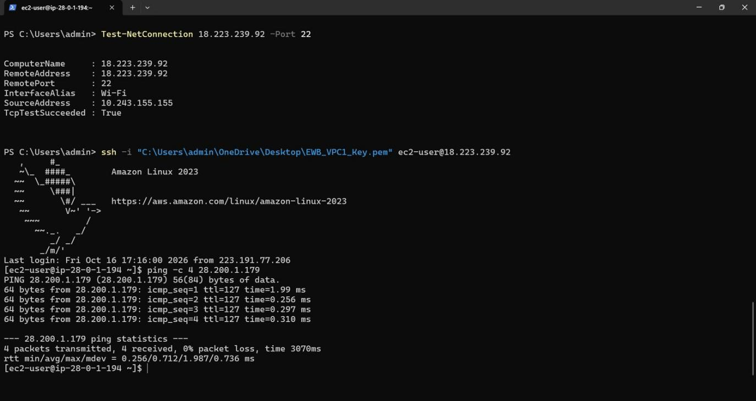
Figure 14. Laptop PowerShell: TCP 22 test to 18.223.239.92 (TcpTestSucceeded True), SSH into EWB_VPC1_EC2, then ping -c 4 28.200.1.179: 4 sent, 4 received, 0% loss.
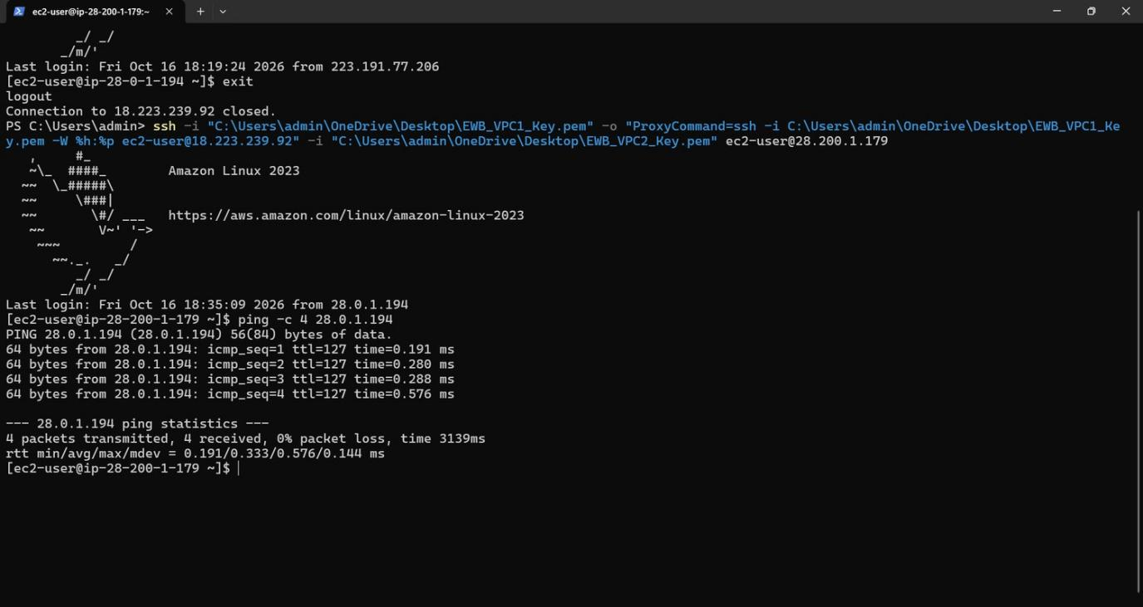
Figure 15. SSH into EWB_VPC2_EC2 through 18.223.239.92, then ping -c 4 28.0.1.194: 4 sent, 4 received, 0% loss.
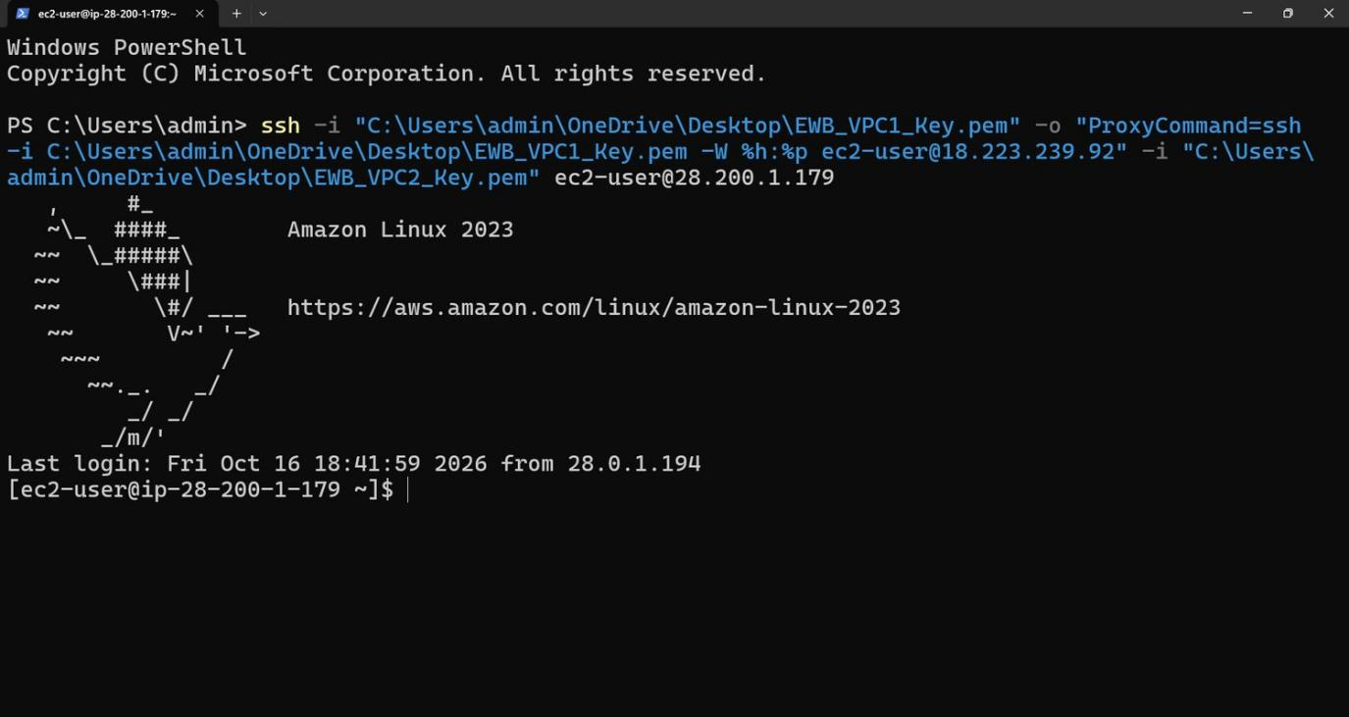
Figure 16. SSH to ec2-user@28.200.1.179 through EWB_VPC1_EC2. The prompt shows ip-28-200-1-179 and the banner shows a last login from 28.0.1.194.

09 / FAILURE AND RECOVERY

ICMP failure and recovery
What my screenshots show and what they do not.
Step | Command (from EWB_VPC1_EC2) | Result | Figure
Failure | ping -c 4 28.200.1.179 | 4 sent, 0 received, 100% packet loss, time 3124 ms | Fig 17
Recovery | ping -c 4 28.200.1.179 | 4 sent, 4 received, 0% loss; rtt min/avg/max 0.267/0.327/0.472 ms | Fig 18

What I cannot show
In the workbook, the controlled failure is done by removing the destination's inbound ICMP Echo rule and adding it back. I do not have a screenshot of a rule being removed or restored, and the VPC2 security group screenshot (Figure 11) shows the ICMP rule in place. So the 100% loss and the later 0% loss are real results, but I cannot say from my screenshots what caused the failure. It also cannot count as a before-peering baseline, because the peering connection and routes were already in place in my other screenshots.

In general, when ping fails while the peering connection is Active, the problem is usually a route, a security group, a network ACL or the instance firewall, not the peering connection itself. That is general VPC behaviour. My screenshots do not prove it for this case.
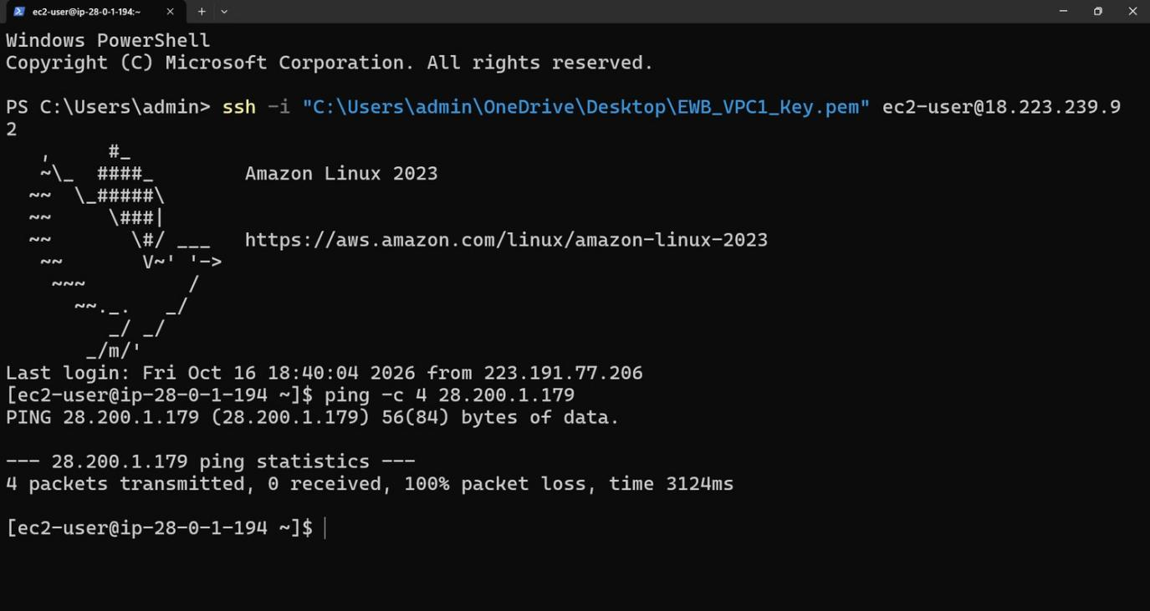
Figure 17. From EWB_VPC1_EC2: ping -c 4 28.200.1.179 gave 4 sent, 0 received, 100% packet loss. The screenshot does not show the cause.
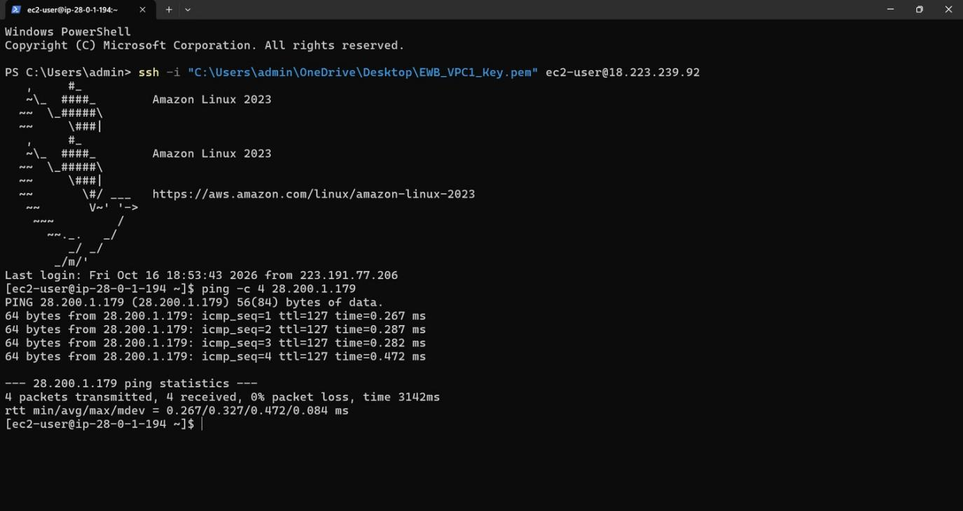
Figure 18. From EWB_VPC1_EC2: ping -c 4 28.200.1.179 gave 4 sent, 4 received, 0% packet loss, after the failure in Figure 17.

10 / TRAFFIC PATHS

Forward path and return path
Why both routes and both security rules are needed.

Forward path: EWB_VPC1_EC2 (28.0.1.194) to EWB_VPC2_EC2 (28.200.1.179)
- The destination 28.200.1.179 matches 28.200.0.0/16 in EWB_Public_Route_Table, whose target is pcx-003e95287deb1beb7. This route is more specific than 0.0.0.0/0, so the internet gateway route is not used.
- The peering connection delivers the packet into VPC2.
- EWB_VPC2_EC2_SG has to allow it: the ICMP rule allows 28.0.0.0/16 and the SSH rule allows 28.0.1.194/32.

Return path: EWB_VPC2_EC2 back to EWB_VPC1_EC2
- The reply's destination 28.0.1.194 matches 28.0.0.0/16 in rtb-0b76e131c631cd684, which points to the same peering connection.
- Security groups are stateful, so replies to allowed traffic are allowed automatically.
- The reverse ping (Figure 15) shows VPC2 can also start traffic to VPC1. That depends on the VPC1 security group, but its source values are cut off in my screenshot.

Administration path
My laptop connects to 18.223.239.92 on TCP 22 through the internet gateway. From EWB_VPC1_EC2 I then connect to 28.200.1.179 over the peering connection. EWB_VPC2_EC2 has no public IPv4 address and no internet gateway route, so the VPC1 instance is the only way in from my laptop.
11 / CLEANUP

Cleanup and final resource state
Everything I deleted and what the screenshots show.
I have 12 cleanup screenshots. None of the lists had a filter applied. Only the Volumes page shows a time (05:28:49 AM GMT+05:30 on 17 October 2026).
Workbook cleanup step | Status | Figure
Terminate EWB_VPC1_EC2 and EWB_VPC2_EC2 | Done: the Instances list shows no instances in the Region | Fig 19
Delete lab EBS volumes | Done: no volumes in the Region | Fig 20
Delete leftover snapshots | Done: no snapshots owned by the account in the Region | Fig 21
Release Elastic IPs | Done: no Elastic IP addresses in the Region | Fig 22
Remove unused lab key pairs | Done: two deletions confirmed and the Key pairs list is empty | Fig 23
Delete peering connection and peer routes | Done: status Deleted; 3 of 3 related routes deleted | Fig 24
Delete subnets | Done: 3 subnet IDs deleted and the Subnets list is empty | Fig 25
Delete security groups | Done: only the default security group is left | Fig 29
Delete custom route tables | Done: only the default VPC's main route table is left | Fig 27
Detach and delete the internet gateway | Done: the project gateway is not listed; only the default VPC's gateway is left | Fig 28
Delete both VPCs | Done: only the default VPC is left | Fig 26
Check Billing for remaining resources | Month-to-date cost is $0.00 and the forecast says 'Data unavailable'. Billing data can lag, so this does not prove there are no charges. | Fig 30

Things to note
The three deleted subnet IDs are subnet-0ff3d44240c664aee (EWB_Public_Subnet, 28.0.1.0/24), subnet-05938eee98e06f0ea (EWB_Private_Subnet_1, 28.0.2.0/24) and subnet-0a00d6ff16d644620 (the VPC2 subnet; its name is not verified from available evidence, and 28.200.1.0/24 is from my notes). The peering deletion says 3 related routes were deleted, but I only have route table screenshots showing 2 peering routes (Figures 7 and 8). VPC1 also had rtb-03c5f665332812b42, and I did not capture its routes after peering.

Final resource state
In my last screenshots for us-east-2 there are no EC2 instances, volumes, snapshots, Elastic IPs or key pairs. The peering connection shows Deleted and there are no subnets. Only the default VPC remains, with its own main route table, internet gateway and default security group. None of my project's VPCs, route tables, internet gateway or security groups are listed.
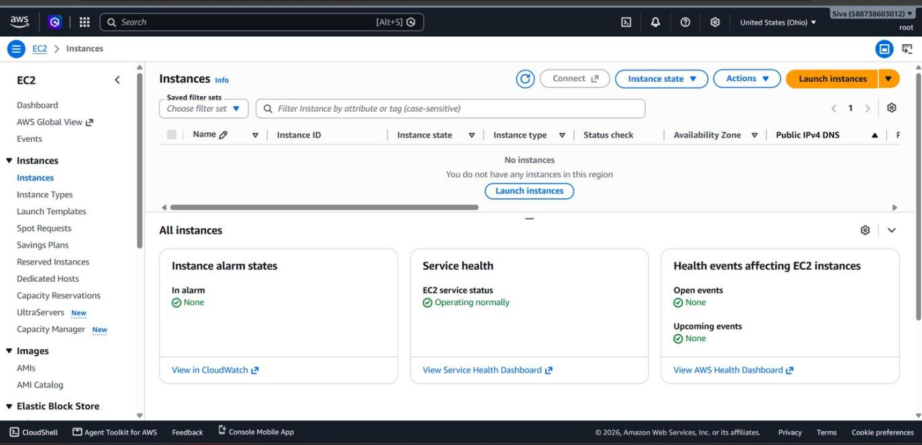
Figure 19. Cleanup, instances: the Instances list (no filter) says 'You do not have any instances in this region'.
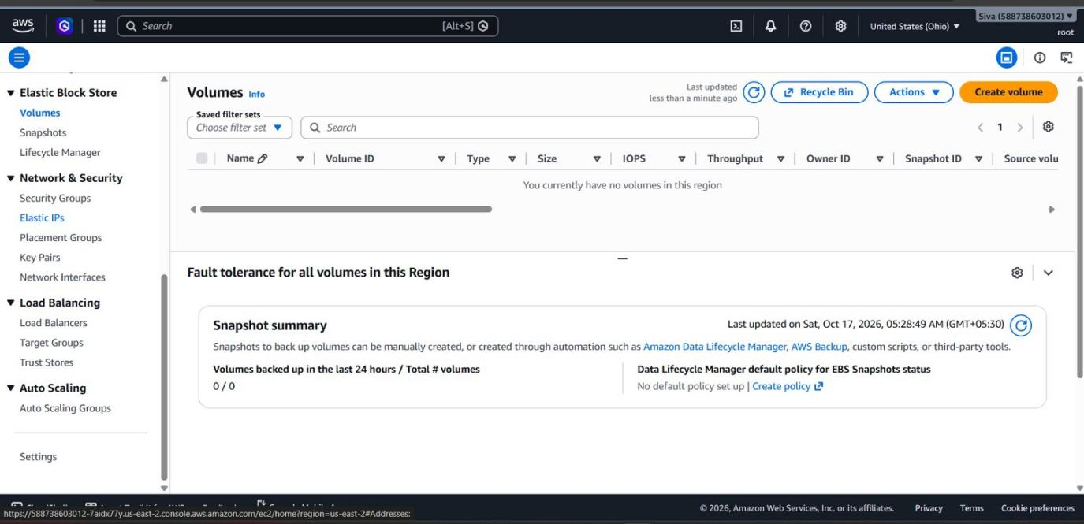
Figure 20. Cleanup, volumes: 'You currently have no volumes in this region'. Snapshot summary 0 / 0 (page time Sat, Oct 17, 2026, 05:28:49 AM GMT+05:30).
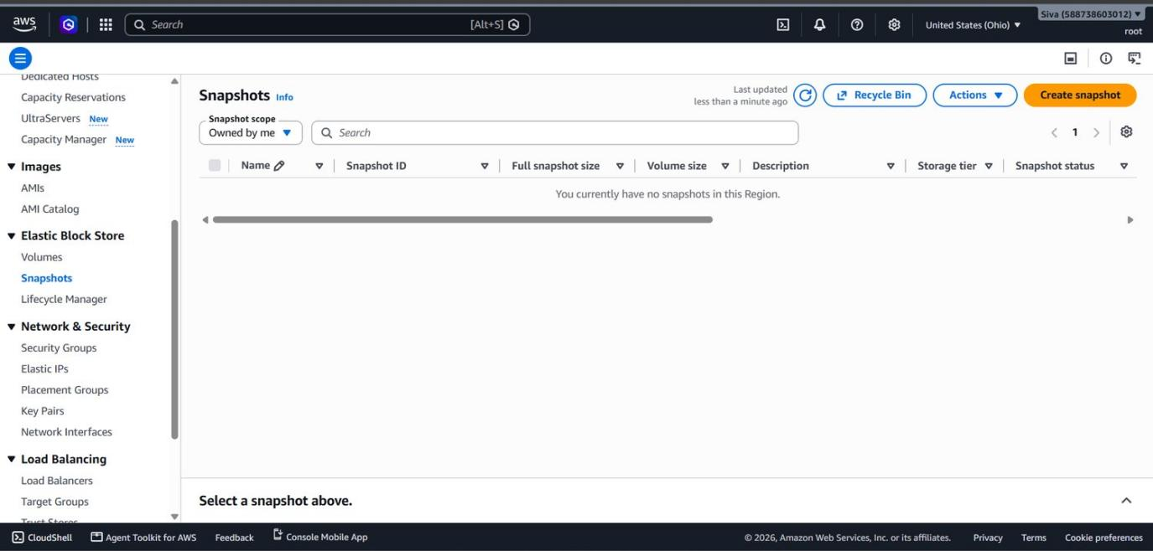
Figure 21. Cleanup, snapshots (Owned by me): 'You currently have no snapshots in this Region'.
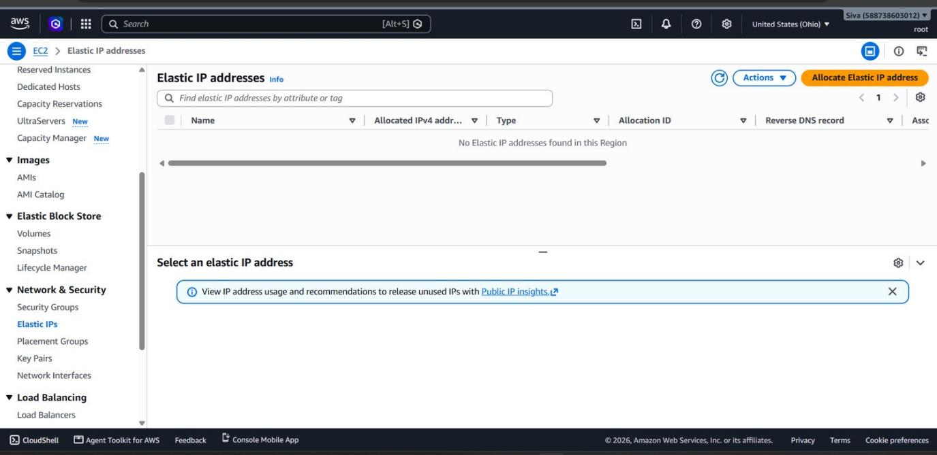
Figure 22. Cleanup, Elastic IPs: 'No Elastic IP addresses found in this Region'.
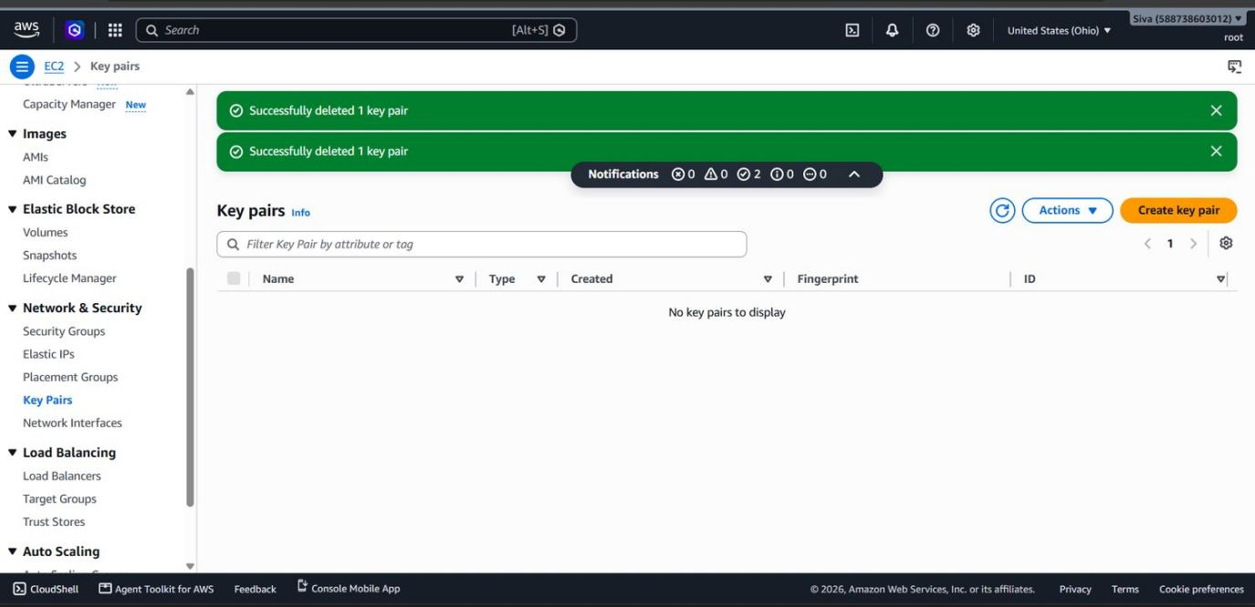
Figure 23. Cleanup, key pairs: two 'Successfully deleted 1 key pair' messages and an empty list. (My earlier screenshot of EWB_VPC1_Key and EWB_VPC2_Key is not included.)
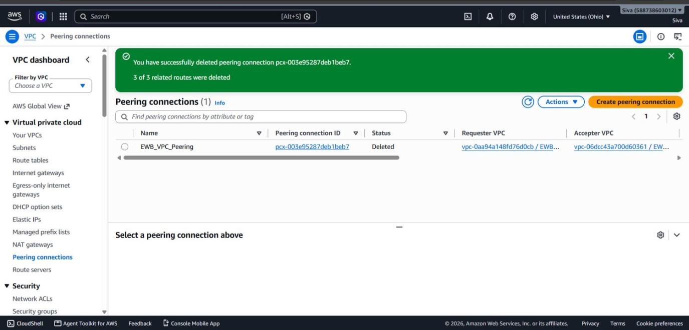
Figure 24. Cleanup, peering: pcx-003e95287deb1beb7 (EWB_VPC_Peering) now shows Deleted, and the console says 3 of 3 related routes were deleted.
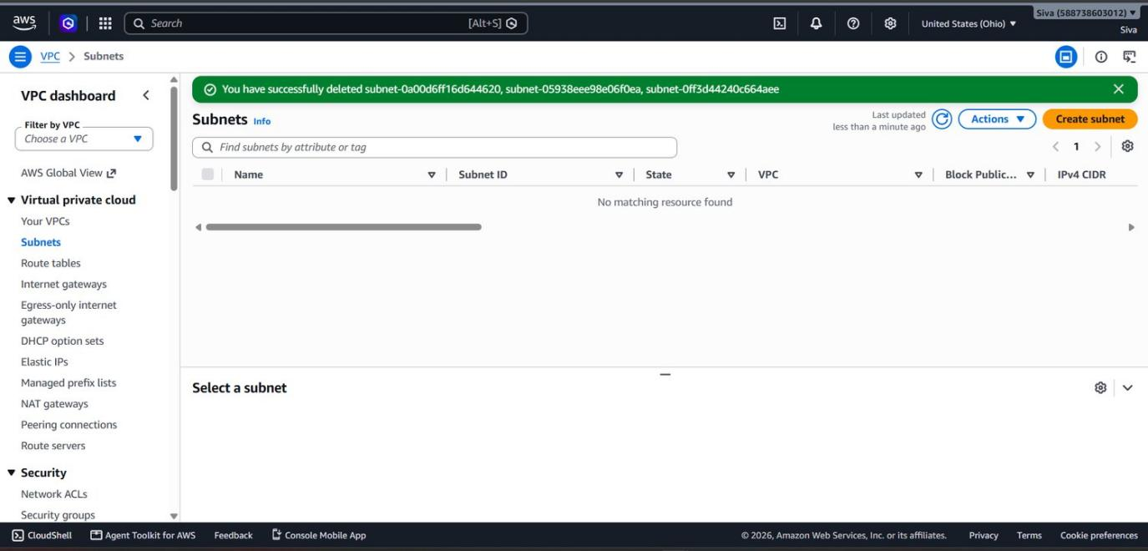
Figure 25. Cleanup, subnets: subnet-0a00d6ff16d644620, subnet-05938eee98e06f0ea and subnet-0ff3d44240c664aee were deleted, and the Subnets list is empty.
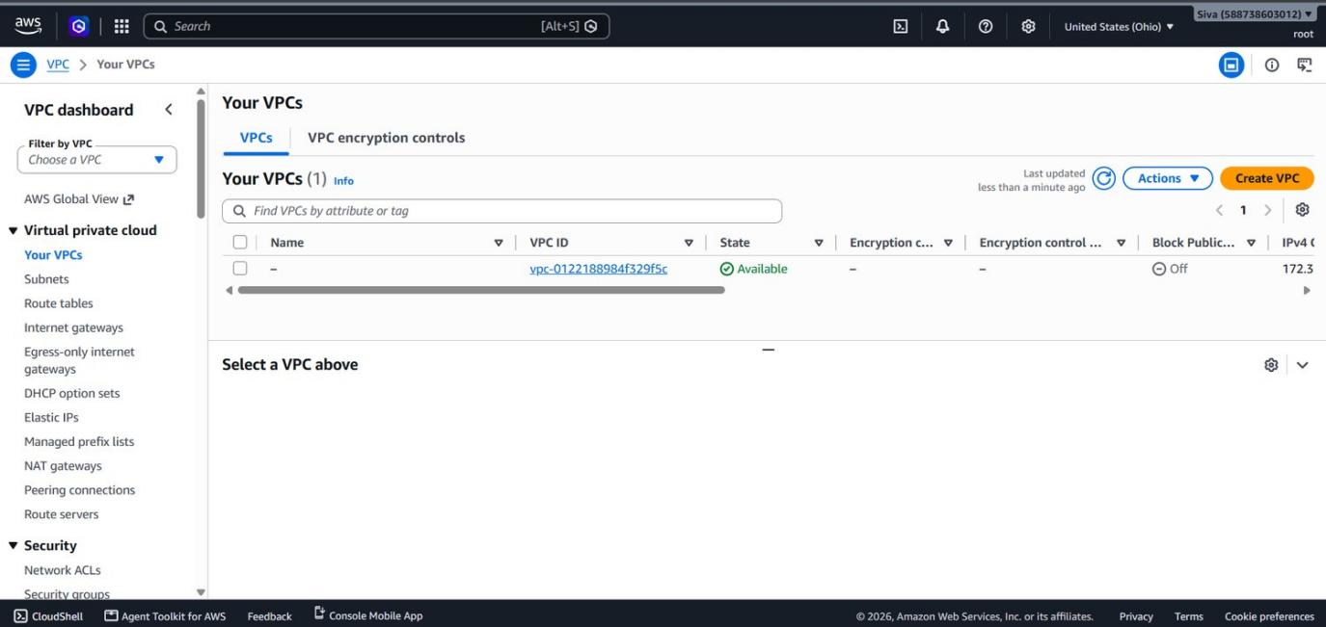
Figure 26. Cleanup, VPCs: only vpc-0122188984f329f5c (the default VPC) is left. Neither project VPC is listed.
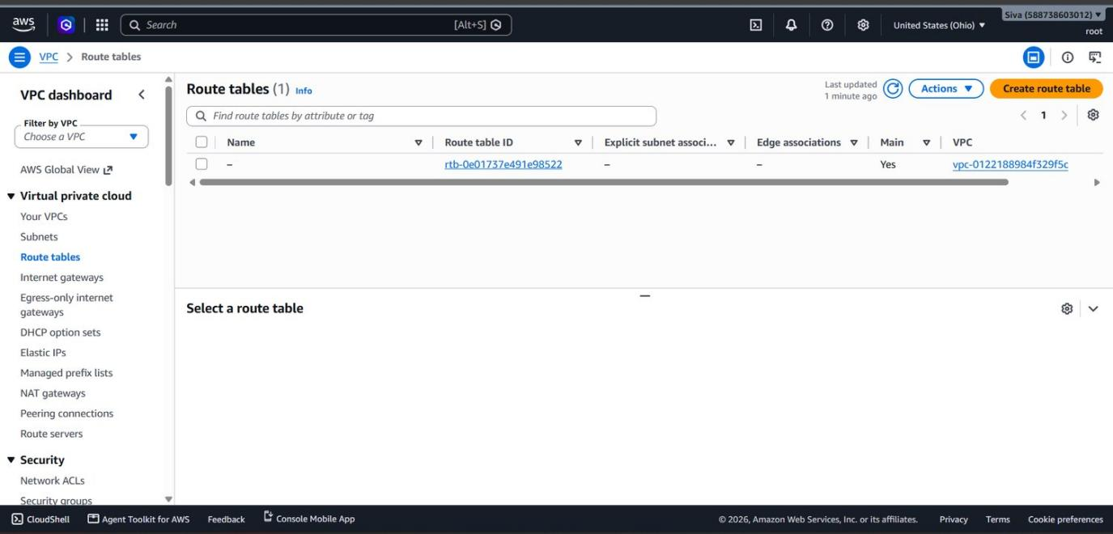
Figure 27. Cleanup, route tables: only rtb-0e01737e491e98522 (Main: Yes) of the default VPC is left.

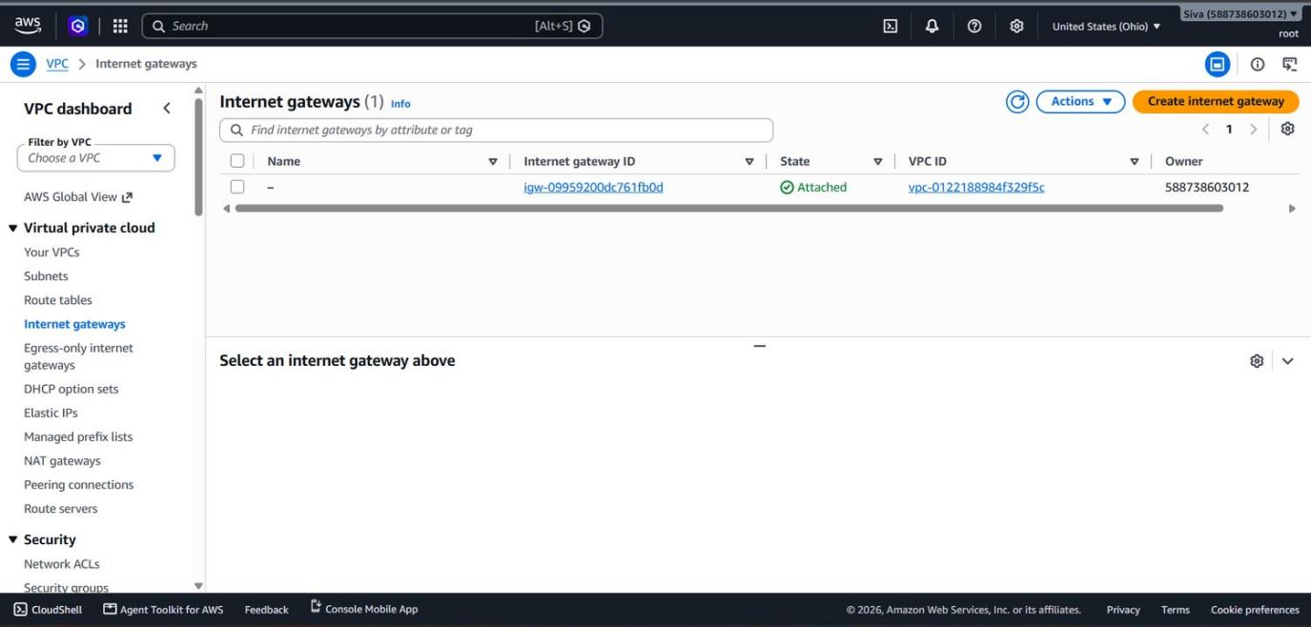
Figure 28. Cleanup, internet gateways: only igw-09959200dc761fb0d, attached to the default VPC. The project gateway igw-0425eaee6f5c8e617 is not listed.
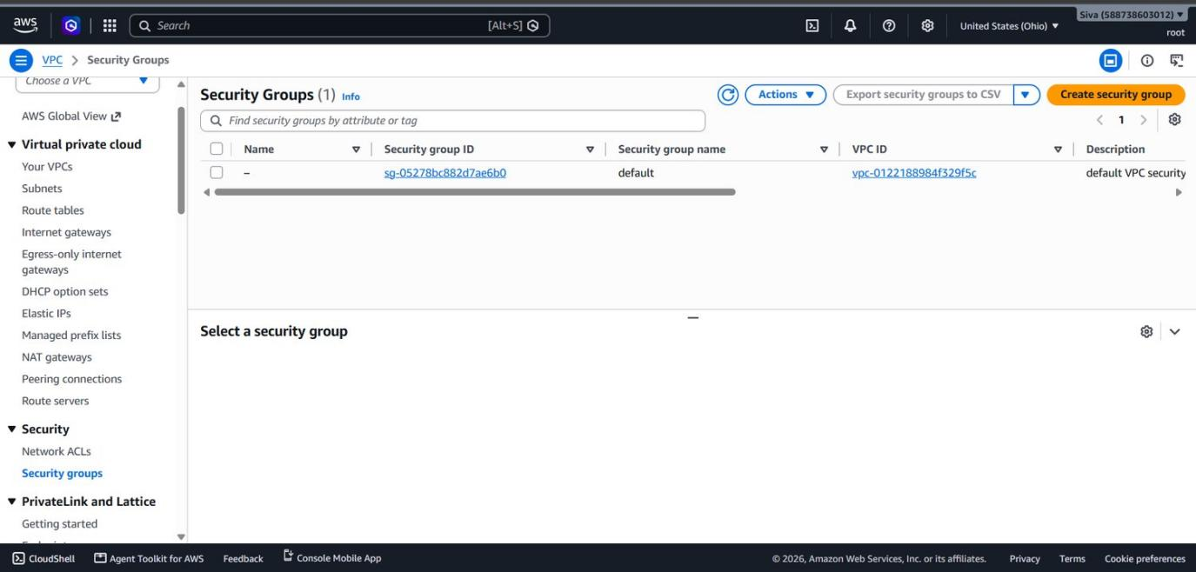
Figure 29. Cleanup, security groups: only the default group sg-05278bc882d7ae6b0 is left. EWB_VPC1_EC2_SG and EWB_VPC2_EC2_SG are not listed.
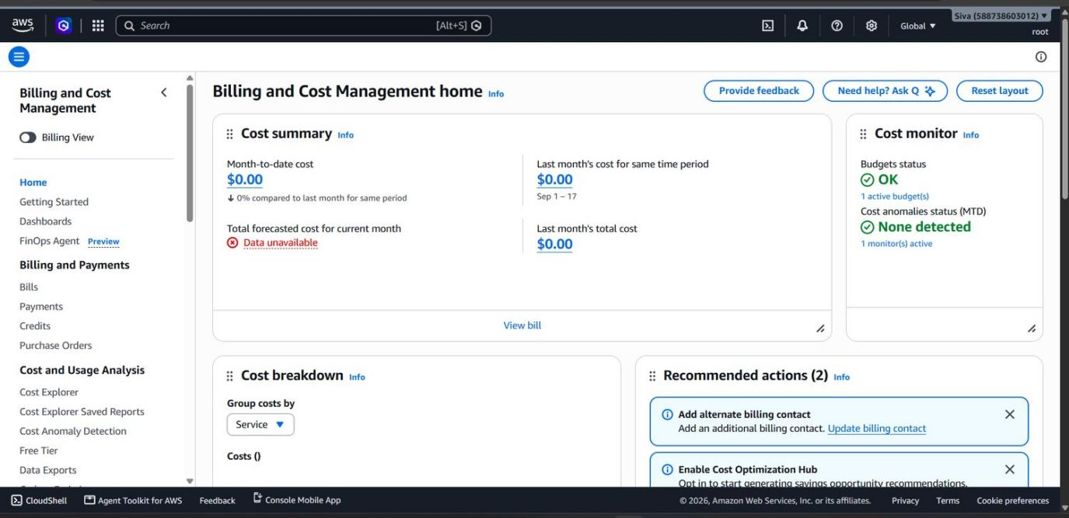
Figure 30. Billing home: month-to-date cost $0.00, last month $0.00, budgets OK, forecast 'Data unavailable'. Billing data can lag.

12 / REFLECTION

What I learned and conclusion
My notes on the project.

Learning note
During this internship, I gained practical experience in AWS networking and learned how different cloud resources work together. Working on the VPC Peering project helped me understand how to connect two separate Virtual Private Clouds and enable communication between instances using their IP addresses inside the VPCs.
I also learned the importance of route tables, security groups, and network rules in controlling communication between resources. Testing connectivity through ping and SSH helped me understand how to troubleshoot network issues and identify configuration mistakes.
Overall, this project gave me a better understanding of AWS networking beyond theoretical concepts. It also taught me the importance of checking configurations carefully, testing connectivity step by step, and cleaning up resources after completing a lab. This experience has increased my confidence in working with cloud technologies and motivated me to learn more about AWS and cloud infrastructure.

Observations from my setup
- The ICMP rule on the VPC2 security group allows the whole VPC1 CIDR (28.0.0.0/16). It could be limited to the VPC1 instance's IP. The SSH rule for 223.191.77.27/32 on VPC2 is also not needed, because that instance has no public IP.
- I do not have a screenshot of the security group change around the failed ping, so I cannot say why it failed. Next time I will capture each change as I make it.
- 28.0.0.0/16 and 28.200.0.0/16 are not private (RFC 1918) ranges. They worked for this lab, but a real network should use RFC 1918 ranges such as 10.0.0.0/8.

Conclusion
I connected two VPCs in us-east-2 with an Active peering connection and added routes on both sides. My setup differs from the workbook design: I used two instances, and the VPC1 instance has a public IPv4 address. Ping worked in both directions (4 of 4 replies each way), and I logged in by SSH to the instance with no public IP through the VPC1 instance. I did not capture a ping or SSH test from before peering, and I cannot say what caused the one failed ping. All the resources listed in Section 11 were deleted, including the key pairs. The remaining gaps are listed in Appendix B.

APPENDIX A / SCREENSHOT INDEX

Screenshot index
Original files, figure numbers and the sections they belong to.
Figure | File | Section
Fig 1 | Diagram drawn for this report (not a screenshot) | 2
Fig 2 | 13_Architecture_and_Resource_Inventory_png.png | 3
Fig 3 | Subnets list screenshot (from my earlier report draft, taken 16-10-2026 19:07) | 4
Fig 4 | 1792195542050_Screenshot_2026-10-16_190831.png | 4
Fig 5 | 1792195551828_Screenshot_2026-10-16_190932.png | 4
Fig 6 | 1792195622742_Screenshot_2026-10-16_191945.png | 4
Fig 7 | 04_Third_Route_Table_png.png | 4
Fig 8 | 03_VPC2_Route_Table_png.png | 4
Fig 9 | 01_VPC_Peering_Active_png.png | 5
Fig 10 | 05_VPC1_Security_Group_png.png | 6
Fig 11 | 06_VPC2_Security_Group_SSH_Rule_png.png | 6
Fig 12 | 07_EC2_Resource_Details_VPC1_png.png | 7
Fig 13 | 07_EC2_Resource_Details_VPC2_png.png | 7
Fig 14 | 08_Forward_Ping_Success_png.png | 8
Fig 15 | 09_Reverse_Ping_Success_png.png | 8
Fig 16 | 10_Private_SSH_App_B_png.png | 8
Fig 17 | 11_Controlled_ICMP_Failure_png.png | 9
Fig 18 | 12_ICMP_Recovery_Success_png.png | 9
Fig 19 | 1792195117119_image.png | 11
Fig 20 | 1792195162272_image.png | 11
Fig 21 | 1792195728641_image.png | 11
Fig 22 | 1792195791773_image.png | 11
Fig 23 | 1792196225843_image.png | 11
Fig 24 | 1792194700314_Screenshot_2026-10-17_005907.png | 11
Fig 25 | 1792194619404_Screenshot_2026-10-17_010300.png | 11
Fig 26 | 1792195211204_image.png | 11
Fig 27 | 1792195251853_image.png | 11
Fig 28 | 1792195276717_image.png | 11
Fig 29 | 1792195332125_image.png | 11
Fig 30 | 1792195872859_image.png | 11

I left out these files because they repeat other screenshots: 02_VPC1_Route_Table (same table as 04), 06_VPC2_Security_Group (an earlier 2-rule view of the group in Figure 11), 14_Cleanup_Evidence and the first

APPENDIX B / COVERAGE

Workbook checklist and remaining gaps
A clear record of what the evidence shows and what it does not show.
Workbook item | Status | Notes
Cover: name, batch, title, region and date | Complete | Included on the cover page.
Architecture diagram and resource inventory | Complete with limitation | Resource IDs and recorded IPs are listed. The VPC2 subnet name is not verified from available evidence.
Subnet CIDRs and route tables | Partly complete | The VPC2 subnet CIDR and Availability Zone are from project notes. The workbook expects three route tables; the available captures do not show every association consistently.
Active peering and security-group rules | Partly complete | Peering status is captured. Some VPC1 security-group source values and outbound rules are not visible in the supplied screenshots.
Baseline failure before peering | Not fully evidenced | A route-table capture before the peering route was added is available, but a matching pre-peering ping or SSH result was not captured.
Forward/reverse ping and SSH to VPC2 | Complete | Screenshots show successful ping in both directions and SSH to the VPC2 instance through VPC1.
Controlled ICMP failure and recovery | Partly complete | Failed and recovered ping results are shown. The security-group rule change itself is not captured, so the exact cause is not confirmed.
Cleanup and learning note | Complete as documented | Cleanup evidence and the learning note are included. The report records the final resource state shown in the evidence.

Final submission note
I have kept the VPC2 subnet name as “Name not verified from available evidence” rather than guessing. The report distinguishes screenshots from details recorded in my notes and lists the remaining evidence gaps. The lab resources have already been cleaned up, so I have not recreated resources just to obtain missing screenshots.

